Beginning a new paragraph
New paragraphs are important for the reader. They tell when you're switching time, place, topic or speaker, and they help break the page up so it is not just a solid block of writing. Seeing that can be discouraging, and you don't want your reader to be discouraged before she even starts to read.
How to do it
There are a few standard times to make a new paragraph:
- When you start in on a new topic
- When you skip to a new time
- When you skip to a new place
- When a new person begins to speak
- When you want to produce a dramatic effect

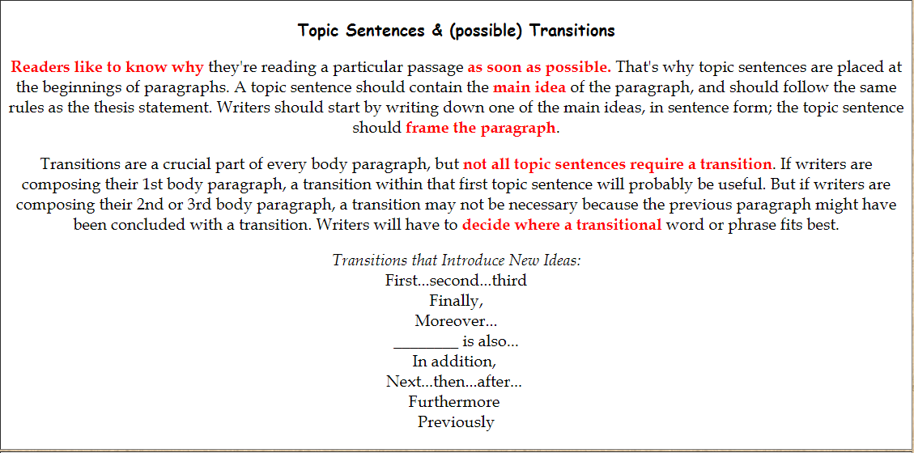

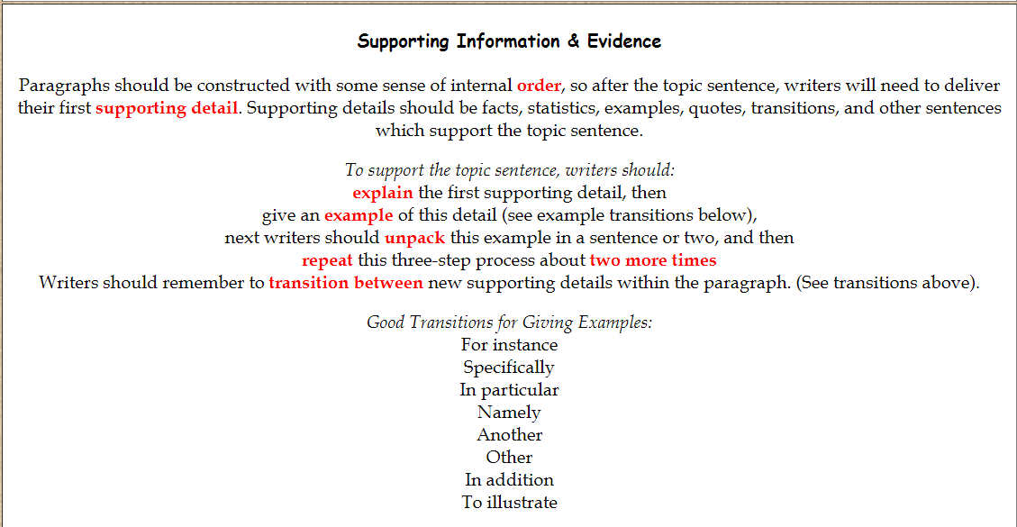

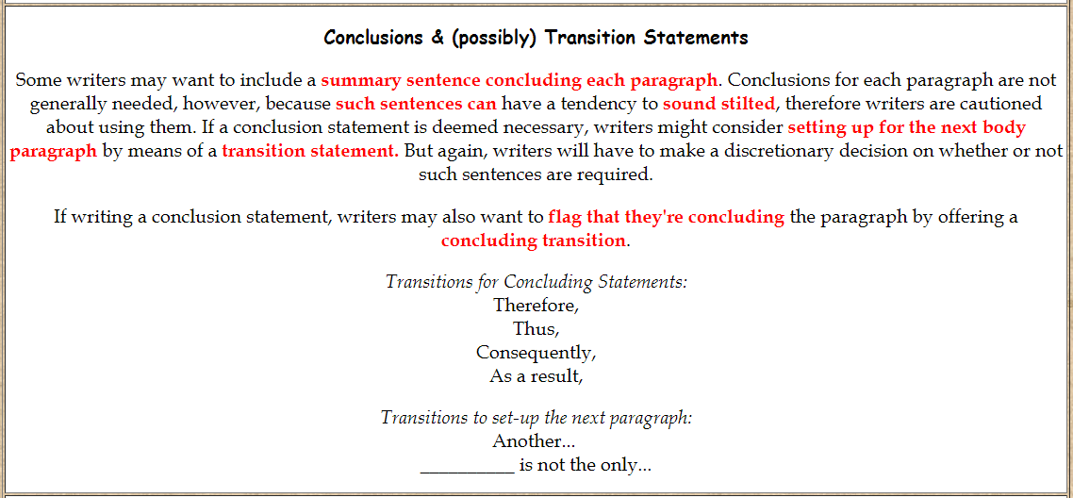

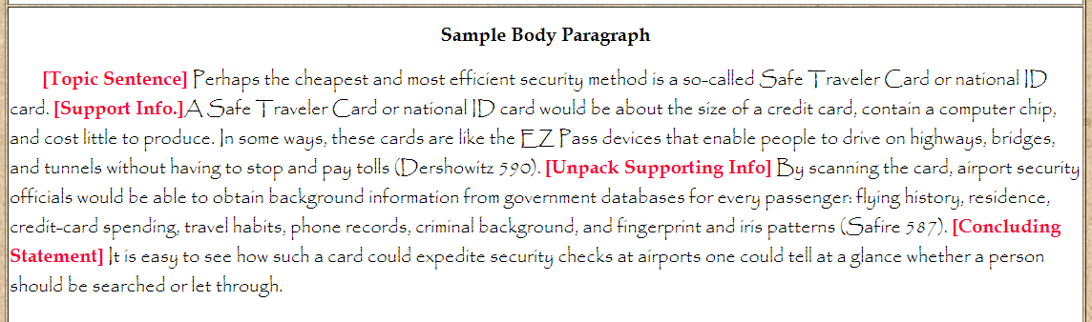
www.mesacc.edu

